LABORATORY 3 – REPORT

## Sahil Mehra - 16403142 - ECE1

*I hereby declare that the attached submission is all my own work, that it has not previously been submitted for assessment, and that I have not knowingly allowed it to be used by another student. I understand that deceiving or attempting to deceive examiners by passing off the work of another as one's own is not permitted. I also understand that using another's student’s work or knowingly allowing another student to use my work is against the University regulations and that doing so will result in loss of marks and possible disciplinary proceedings.*

Note: Coursework examiners are entitled to reject any coursework which does not have a signed copy of this form attached or are submitted late.

## Problem 1

The aim of this problem is to write a C program that prints the following patterns separately, one below the other, using for loops.

### Plan

* Use a for loop to print 5 lines of 11 stars.
* Use set of nested for loops to display an inverted triangle.
* Use another set of nested for loops to display a triangle.

### Development

The first step in the development of my program was to include the standard C libraries (stdio.h, stdlib.h,) that in order to be able to use certain functions in the program.

Then, I started writing up the main function of the program. I used the for loop. In the for loop is used a printf statement to display a single line of 11 stars. I then used a set of nested for loops. In the inner for loop I used a printf statement to display a single star. I let the inner for loop equal the outer for loop This means that as the number of lines increase, the number of stars decrease. The second set of for loops was the same as the first but instead of the numbers of stars decreases with each line, it increases.

### Testing

I compiled and tested the program using the gcc compiler. I was not presented any errors when I compiled my code.

The program ran smoothly without any errors

### Conclusion

During this lab session I learned about some of the functions contained in the stdio.h and stdlib.h libraries (e.g. functions).

The final version of the C source code for problem 2 is attached as problem1_B.c

## Problem 2

The aim of this problem is to write a C program that will input a series of lines of characters, and encode them with a Caesar cipher.

### Plan

* Print a welcoming message
* Ask the user to input a string
* Ask the user to input a number for the key
* Use the key to change the letters by that amount
* Print a goodbye message

### Development

The first step in the development of my program was to include the standard C libraries (stdio.h, stdlib.h, string.h) that in order to be able to use certain functions in the program.

Then, I started writing up the main function of the program. I used the ‘printf’ command to display welcoming message on my screen on my screen and to ask the user for input. I then used a gets statement to store the user input. I then used a printf statement to ask the user for the key and a scanf statement to assign the value to a float. I used a for loop, in which I used a series of if and else statements to change the letters. I then used a printf statement to print out the new series of letters.

### Testing

I compiled and tested the program using the gcc compiler. I was not presented any errors when I compiled my code. 

### Conclusion

During this lab session I learned about some of the functions contained in the stdio.h, stdlib.h and string.h libraries (e.g. if statements)..

The final version of the C source code for problem 3 is attached as problem2.c

## Problem 3

The aim of this problem is to write a C program that reads in the initial height and initial horizontal and vertical components of a projectile. Next, after small intervals of time, the horizontal and vertical component must be calculated. These results will be then exported to a text file. From there these results will be used in excel to create a graph of the projectile.

### Plan

* Print a welcoming message
* Ask the user for input for the initial height and initial horizontal and vertical components of a projectile.
* Do the calculations for the range, total time and maximum height
* Print the answers
* Find the vertical and horizontal displacement after certain times t
* Save these results to a text file
* Output these results to excel and create a graph
* Print a goodbye message

### Development

The first step in the development of my program was to include the standard C libraries (stdio.h, stdlib.h, string.h) that in order to be able to use certain functions in the program.

Then, I started writing up the main function of the program. I used the ‘printf’ command to display welcoming message on my screen on my screen. I used a void function to ask for the input from the user. I then used another void function to do the calculations for the range total time and maximum height. I then used another void function to find the vertical and horizontal displacement after certain times t.s

### Testing

I compiled and tested the program using the gcc compiler. I was not presented any errors when I compiled my code. 

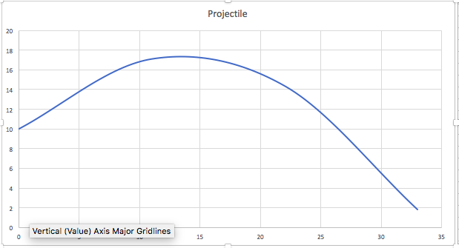

### Conclusion

During this lab session I learned about some of the functions contained in the stdio.h, stdlib.h and string.h libraries (e.g. for loops)..

The final version of the C source code for problem 4 is attached as problem4_3.c